Nurul Fitri Ansoriyati

**13.3 Tugas SQL_Join**



1. **Membuat database menggunakan command prompt**

Microsoft Windows [Version 10.0.22631.3880]

(c) Microsoft Corporation. All rights reserved.

C:\Users\Fitri>mysql -u root -p

Enter password: **********

Welcome to the MySQL monitor. Commands end with ; or \g.

Your MySQL connection id is 23

Server version: 8.0.39 MySQL Community Server - GPL

Copyright (c) 2000, 2024, Oracle and/or its affiliates.

Oracle is a registered trademark of Oracle Corporation and/or its

affiliates. Other names may be trademarks of their respective

owners.

Type 'help;' or '\h' for help. Type '\c' to clear the current input statement.

mysql> CREATE DATABASE Sql_Join;

Query OK, 1 row affected (0.03 sec)

mysql> USE Sql_Join

Database changed

mysql> CREATE TABLE users (

-> id INTEGER PRIMARY KEY,

-> email VARCHAR(255) NOT NULL,

-> name VARCHAR(255) NOT NULL,

-> password VARCHAR(255) NOT NULL,

-> address VARCHAR(255),

-> role VARCHAR(50),

-> status VARCHAR(50),

-> created_at TIMESTAMP DEFAULT CURRENT_TIMESTAMP,

-> updated_at TIMESTAMP DEFAULT CURRENT_TIMESTAMP ON UPDATE CURRENT_TIMESTAMP

-> );

Query OK, 0 rows affected (0.06 sec)

mysql> INSERT INTO users (id, email, name, password, address, role, status) VALUES

-> (1, 'john.doe@example.com', 'John Doe', 'password123', '123 Main St', 'admin', 'active'),

-> (2, 'jane.smith@example.com', 'Jane Smith', 'password456', '456 Elm St', 'user', 'inactive'),

-> (3, 'michael.jones@example.com', 'Michael Jones', 'password789', '789 Oak St', 'user', 'active');

Query OK, 3 rows affected (0.02 sec)

Records: 3 Duplicates: 0 Warnings: 0

mysql> SELECT * FROM users;

+----+---------------------------+---------------+-------------+-------------+-------+----------+---------------------+---------------------+

| id | email | name | password | address | role | status | created_at | updated_at |

+----+---------------------------+---------------+-------------+-------------+-------+----------+---------------------+---------------------+

| 1 | john.doe@example.com | John Doe | password123 | 123 Main St | admin | active | 2024-08-17 10:12:48 | 2024-08-17 10:12:48 |

| 2 | jane.smith@example.com | Jane Smith | password456 | 456 Elm St | user | inactive | 2024-08-17 10:12:48 | 2024-08-17 10:12:48 |

| 3 | michael.jones@example.com | Michael Jones | password789 | 789 Oak St | user | active | 2024-08-17 10:12:48 | 2024-08-17 10:12:48 |

+----+---------------------------+---------------+-------------+-------------+-------+----------+---------------------+---------------------+

3 rows in set (0.00 sec)

mysql> CREATE TABLE products (

-> id INTEGER PRIMARY KEY,

-> category_id INTEGER,

-> user_id INTEGER,

-> code VARCHAR(50) NOT NULL,

-> name VARCHAR(255) NOT NULL,

-> slug VARCHAR(255),

-> description LONGTEXT,

-> photo VARCHAR(255),

-> qty DOUBLE,

-> unit VARCHAR(50),

-> price DOUBLE,

-> status VARCHAR(50)

-> );

Query OK, 0 rows affected (0.03 sec)

mysql> INSERT INTO products (id, category_id, user_id, code, name, slug, description, photo, qty, unit, price, status) VALUES

-> (1, 1, 1, 'P001', 'Product One', 'product-one', 'This is the first product.', 'photo1.jpg', 100, 'pcs', 19.99, 'available'),

-> (2, 2, 2, 'P002', 'Product Two', 'product-two', 'This is the second product.', 'photo2.jpg', 50, 'pcs', 29.99, 'available'),

-> (3, 3, 1, 'P003', 'Product Three', 'product-three', 'This is the third product.', 'photo3.jpg', 75, 'pcs', 39.99, 'out of stock');

Query OK, 3 rows affected (0.02 sec)

Records: 3 Duplicates: 0 Warnings: 0

mysql> SELECT * FROM products;

+----+-------------+---------+------+---------------+---------------+-----------------------------+------------+------+------+-------+--------------+

| id | category_id | user_id | code | name | slug | description | photo | qty | unit | price | status |

+----+-------------+---------+------+---------------+---------------+-----------------------------+------------+------+------+-------+--------------+

| 1 | 1 | 1 | P001 | Product One | product-one | This is the first product. | photo1.jpg | 100 | pcs | 19.99 | available |

| 2 | 2 | 2 | P002 | Product Two | product-two | This is the second product. | photo2.jpg | 50 | pcs | 29.99 | available |

| 3 | 3 | 1 | P003 | Product Three | product-three | This is the third product. | photo3.jpg | 75 | pcs | 39.99 | out of stock |

+----+-------------+---------+------+---------------+---------------+-----------------------------+------------+------+------+-------+--------------+

3 rows in set (0.00 sec)

mysql> CREATE TABLE categories (

-> id INTEGER PRIMARY KEY,

-> user_id INTEGER,

-> code VARCHAR(50) NOT NULL,

-> name VARCHAR(255) NOT NULL,

-> slug VARCHAR(255),

-> description TEXT,

-> status VARCHAR(50),

-> photo VARCHAR(255)

-> );

Query OK, 0 rows affected (0.03 sec)

mysql> INSERT INTO categories (id, user_id, code, name, slug, description, status, photo) VALUES

-> (1, 1, 'C001', 'Electronics', 'electronics', 'Category for electronic items', 'active', 'electronics.jpg'),

-> (2, 2, 'C002', 'Books', 'books', 'Category for various books', 'active', 'books.jpg'),

-> (3, 1, 'C003', 'Clothing', 'clothing', 'Category for clothes and apparel', 'inactive', 'clothing.jpg');

Query OK, 3 rows affected (0.02 sec)

Records: 3 Duplicates: 0 Warnings: 0

mysql> SELECT * FROM categories;

+----+---------+------+-------------+-------------+----------------------------------+----------+-----------------+

| id | user_id | code | name | slug | description | status | photo |

+----+---------+------+-------------+-------------+----------------------------------+----------+-----------------+

| 1 | 1 | C001 | Electronics | electronics | Category for electronic items | active | electronics.jpg |

| 2 | 2 | C002 | Books | books | Category for various books | active | books.jpg |

| 3 | 1 | C003 | Clothing | clothing | Category for clothes and apparel | inactive | clothing.jpg |

+----+---------+------+-------------+-------------+----------------------------------+----------+-----------------+

3 rows in set (0.00 sec)

mysql> SELECT

-> users.id AS user_id,

-> users.name AS user_name,

-> products.id AS product_id,

-> products.name AS product_name,

-> categories.id AS category_id,

-> categories.name AS category_name

-> FROM

-> users

-> LEFT JOIN

-> products ON users.id = products.user_id

-> LEFT JOIN

-> categories ON products.category_id = categories.id;

+---------+---------------+------------+---------------+-------------+---------------+

| user_id | user_name | product_id | product_name | category_id | category_name |

+---------+---------------+------------+---------------+-------------+---------------+

| 1 | John Doe | 3 | Product Three | 3 | Clothing |

| 1 | John Doe | 1 | Product One | 1 | Electronics |

| 2 | Jane Smith | 2 | Product Two | 2 | Books |

| 3 | Michael Jones | NULL | NULL | NULL | NULL |

+---------+---------------+------------+---------------+-------------+---------------+

4 rows in set (0.00 sec)

1. **Tampilan database di apk HeidiSql**
2. Table categories

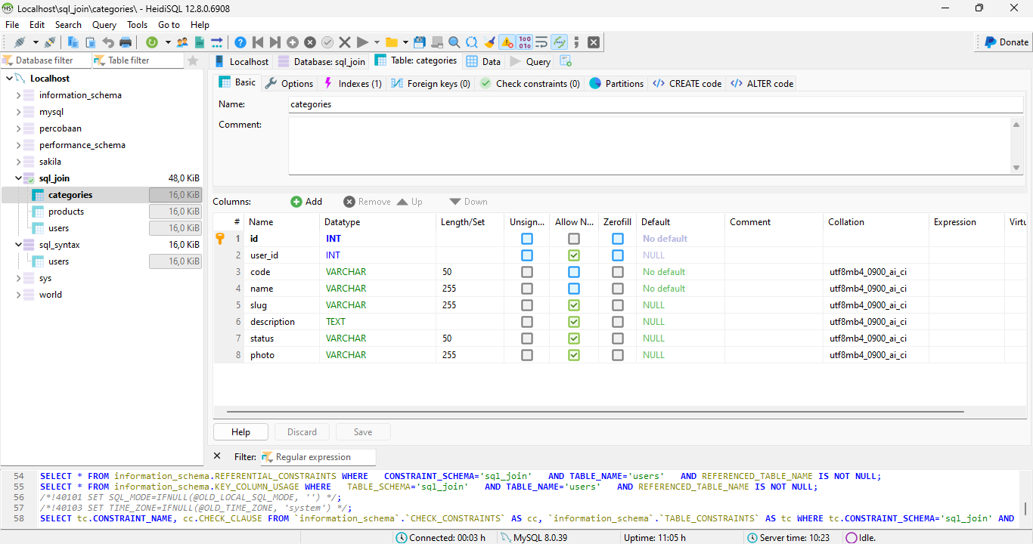

1. Table product

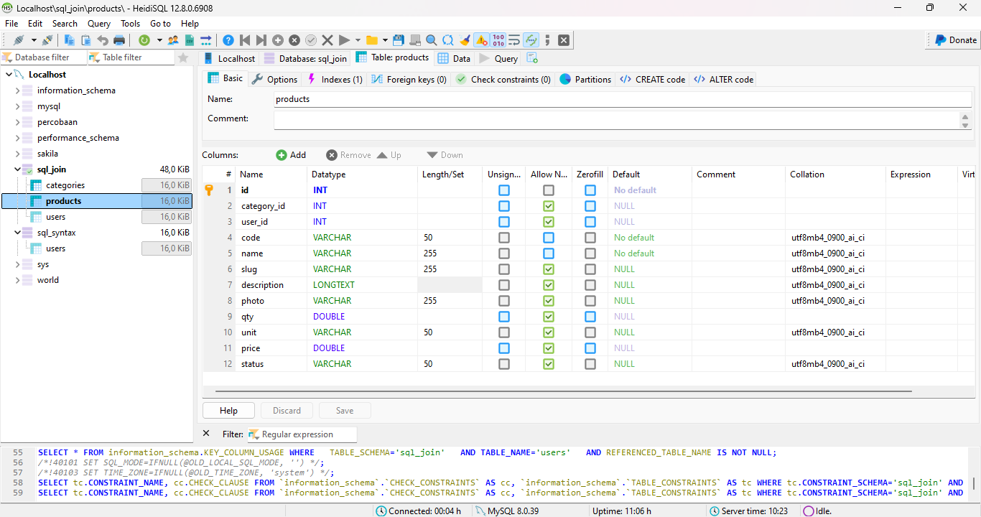

1. Table users

